Purpose: Firefighting is one of the most physically demanding occupations in today’s society. History has proven that firefighting is also one of the deadliest professions to be in as well. In an effort to provide for the safety and well-being of the firefighter both in relation to work place activities and off-duty life, a strong emphasis has been placed on firefighter safety and physical training over the last several years. This physical training and physical well-being is encompassed in a variety of ways. Correct eating habits, a proper and well-balanced nutritious menu at all times and regular cardiovascular and weight training are but to name a few aspects to consider for a healthy lifestyle.

Applicability:
1. Fitness evaluations are non-punitive and used solely for the purpose of evaluating the individual against his/her previous fitness evaluations or to establish a baseline for that individual.
2. Fitness evaluations are mandatory for all firefighters as part of the comprehensive wellness fitness program as required by NFPA 1583, Standard on Health-Related Fitness Programs for Firefighters, and should be conducted under the guidance of the Fire Department Physician.
3. The actual evaluations shall be performed by the Fire Department Fitness Personnel.
4. All data collected by the Health Fitness Coordinator’s (HFC’s) are considered clinical in nature and shall be maintained in the member’s confidential medical file.
5. All firefighters will be assessed on an annual basis for fitness levels.
6. A member that has not passed at least 3 of the 5 assessment areas as prescribed by the current Okolona Fire Department fitness standard form from their most recent assessment per the HFC will not be eligible for promotional opportunities and participation in outside schools and conferences unless directed by the Fire Chief.
For promotional evaluation see, “Career Firefighter Promotion Recommendation Lists” policy.

Goals:
The Department’s commitment combined with an equal commitment by each member will ensure that the goals of the program are realized.
The goals of the program are:
• Ensure that members have the physical attributes required for the proper performance of their duties.
• To reduce the frequency and severity of injuries and illness.
• To extend the health and longevity of department members.

The basic duties of a firefighter require above average levels of fitness. The tasks that firefighters are faced with on the fire ground are extremely demanding physically. These tasks are usually performed without any warm-up and under environmentally hostile conditions. This set of circumstances is conducive to a very high risk of injury. If injuries are going to be reduced, the capacity to endure the physical demands of firefighting must be increased.

Regular physical fitness activities are very important to the total well-being of the firefighters. Participating in them not only helps to reduce injuries; it also increases strength and stamina, keeps our minds alert and releases various forms of personal stress.

It is recognized that the state of being physically fit is more important than the actual program we follow to attain that fitness. Therefore, a considerable amount of discretion is allowed in selecting a physical activity from a large menu of options. However, it is imperative that we manage our participation, discipline our actions and follow our personal training goals and objectives. Equally as important is the need to follow a few specific guidelines concerning company participation in all of our physical training activities.

Acceptable Activities:
The Company Officer, with the approval of their Battalion Chief, regulates the type of activities pursued. It is the Company Officer's responsibility to ensure that fitness activities are consistent with guidelines presented and that they are performed in a manner that minimizes possible injuries.

While the Company Officer is responsible for the daily oversight of fitness training, it should be noted that each individual is responsible for obeying safe practices and all rules of the workout area being used. Any injuries and/or accidents shall be reported to employee’s immediate supervisor and all proper documentation shall be completed.

Physical fitness programs should include activities to improve aerobic fitness, flexibility, body composition, muscular strength and endurance. They should be non-contact activity pursued in a safe manner. Recommended fitness programs may include, but are not limited to, resistance training, functional training, circuit training and group fitness training.

Attire:
Members shall dress appropriately for comfort, maximum range of motion, as well as to consider the comfort of others. Strapless blouses, bathing suits, visible undergarments/sports bras and shirts that show the midriff are not permitted. Clothing that is too tight, too revealing, or contains profane language or slogans are not permitted. T-shirts, sweatshirts, and exercise tops should cover the full torso to prevent ringworm, MRSA, and other infections from being passed from skin to pad/mat contact. Torso is defined as the trunk of a human body consisting of the chest, abdomen, back and sides. Members shall clean machines and equipment after use.

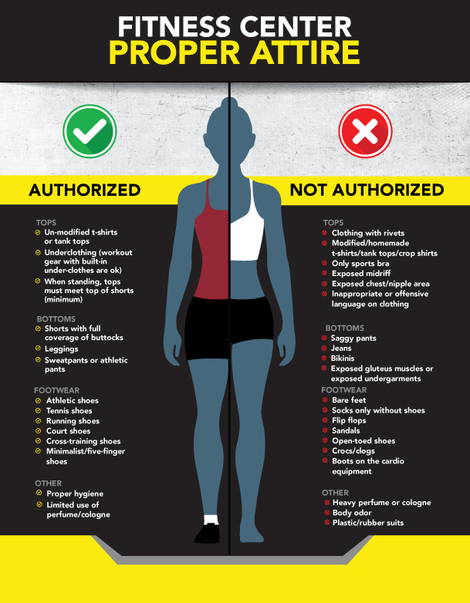
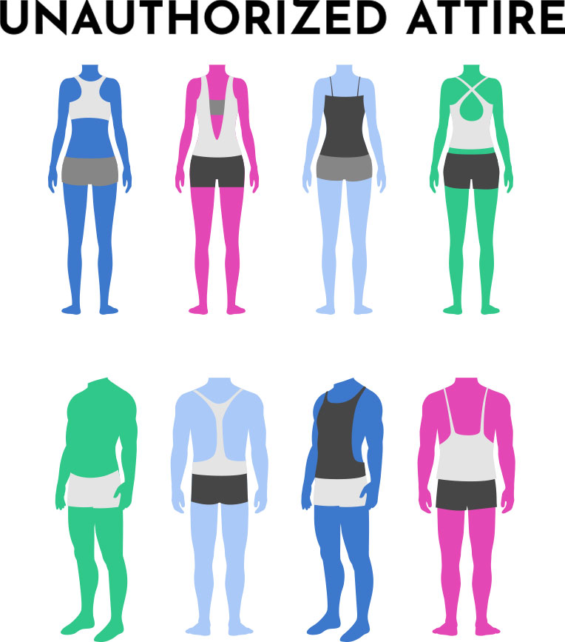
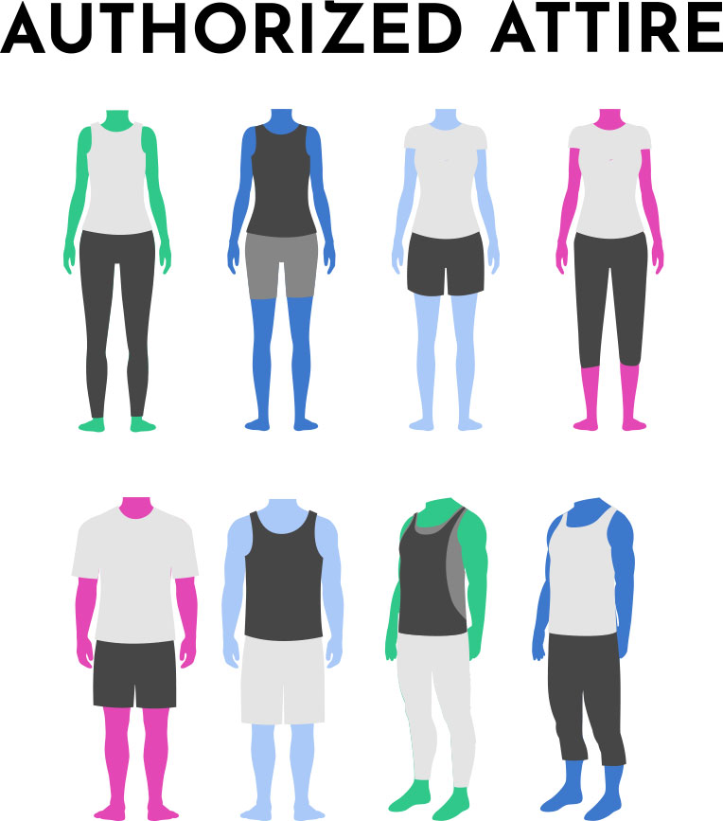

Physical Fitness Evaluation:
The “Physical Fitness Evaluation” will be conducted annually for all members of the Okolona Fire District, excluding members assigned to administrative staff. The purpose is to evaluate the overall physical readiness of members and to ensure the individual fitness level of each member meets the minimum fitness requirements of the department. Although, assigned administrative staff are excluded from the “Physical Fitness Evaluation”; they are encouraged to participate in physical fitness.

Assessments:

Components:
1. The individual fire department physician shall clear all firefighters for participation in the fitness assessment. This clearance can come in the form of a “fit for duty” issued by the department physician. This clearance shall be submitted to the departments Health Fitness Coordinator or his/her designate.
2. If a firefighter has an acute medical problem or a newly acquired chronic medical condition, the fitness assessment shall be postponed until that person has recovered from this condition and presents to the fire department Medical Officer for review. Such condition shall be documented by a physician’s letter.
3. All firefighters (career and part time) shall be assessed physically on a yearly basis. The assessment complies with NFPA 1583.
4. All on duty firefighters working a 24-hour schedule will be required to perform physical fitness/training for a minimum of 60 minutes each day the firefighter is scheduled to work a 24-hour shift. All workouts are encouraged to be done as a group. Any member who does not comply will be subject to KRS 75.130 disciplinary proceedings.
5. All on duty firefighters working a 40-hour schedule will be required to perform physical fitness/training for a minimum of 2.5 hours per week.
6. All part-time employees should be encouraged to perform physical fitness/training and given the same opportunity as full-time firefighters, as their assigned daily duties and schedule permit.
7. Firefighters on vacation or holiday are excused from physical fitness/training. No special documentation is required.
8. Any firefighter who is ill or not feeling well during the duty day will be exempt from workout with the approval of the on-duty supervisor.
9. Training, details and other scheduled activities shall not be used for excusal from physical fitness. Time management should be used by the Supervisor to allot the crew a minimum of 60 minutes to perform physical fitness.
10. Any firefighter who does not meet the assessment standards will be sent to the Department’s Peer Fitness Trainer/Health Fitness Coordinator trained personnel for assistance in the area or areas for a plan of improvement. This plan of improvement may include a visit to the department physician or other outside resources for assistance.

11. The actual evaluations shall be performed by the Fire Department Peer Fitness Trainer/Health Fitness Coordinator. All data collected by the evaluators shall be considered clinical in nature, confidential, and maintained in the member’s confidential medical file in accordance to NFPA 1582.
12. An individual that fails to achieve any area of the annual fitness standard shall be given detailed plan of improvement that shall be developed by the Health Fitness Coordinator / Peer Fitness trained personnel on how to achieve the desired fitness level.

13. The individual that failed to meet the annual fitness standard is strongly encouraged at the member’s request to be re-evaluated to ensure that there is an improvement in their fitness status based upon their previous most recent fitness evaluation.
14. The Supervisor of the member that has failed to meet any portion of the fitness assessment shall report this confidential information to their Assistant Chief or Shift Chief for monitoring and follow-up.
15. The Assistant Chief or Shift Chief shall forward this confidential information to the Chief and Training Officer for monitoring purposes.
16. Failing to pass the fitness assessment is non-punitive. However, failing to undergo the fitness standard is grounds for KRS 75.130 disciplinary action.
17. Career firefighters who have not undergone the fitness assessment by the end of the calendar year unless approved by the Fire Chief in advance, in consultation with the HFC, shall not be placed on the overtime eligibility list until completion of the assessment.

Assessment Areas:

1. Aerobic Capacity
1.5 mile walk/run
Rationale: The 1.5 mile run is designed to test the firefighter’s physical and muscular strength and endurance
Directions: The firefighter, wearing ordinary workout or exercise clothing, must run or walk a measured distance of 1.5 miles.
Standard: The firefighter must complete the 1.5 run within 17 minutes and 15 seconds or complete the walk within 24 minutes and 30 seconds.
Alternative: Cycle Test- Only firefighters who are medically excused from running or walking will take the Cycle Test are those This excusal must be documented in the form a physician letter. All others will run or walk 1.5 miles as part of the fitness standard.

Cycle Test: The cycle test is a 12-minute fixed time test with a direct correlation to the 1.5 mile run. The goal is to burn as many calories as possible. Once the user obtains their caloric output from the stationary bike, the results shall be input into a calculator that will convert the result comparable with a 1.5 mile run section of the physical readiness test. The calculator can be found on the “Official Navy

PFA App” under the PFA Calculator Section > Physical Readiness Test Section of the application. The minimum passing score is the “Good Low” range.

2. Muscular Strength
Definition: The maximal amount of force a muscle or group of muscles can exert in a single contraction; the ability to apply force.
Directions: The firefighter given a weight bench and free weights will bench press his or her body weight for one (1) repetition.

Alternate:
Directions: The firefighter given a weight bench and free weights will bench press 2/3 of his or her body weight for five (5) repetitions.
Standard: The firefighter will raise the required amount of weight using all safety precautions necessary to achieve the weight required.

3A. Muscular Endurance
Definition: The ability of the muscle to perform repeated contraction for a prolonged period of time; the ability of the muscle to persist.
Directions: The firefighter given a flat surface will perform twenty (20) push-ups in the time standard.
Standard: The firefighter will perform twenty (20) push-ups in a maximum of time of one (1) minute.

3B. Muscular Endurance Continued
Directions: The firefighter given a flat surface and a spotter or exercise ball will perform thirty (30) sit-ups.
Standard: The firefighter will perform the 30 sit-ups in the maximum time of one (1) minute.
Alternatives:
a. Static Plank- The calculator for this option can be found on the “Official Navy PFA App” under the PFA Calculator Section > Physical Readiness Test Section of the application. The minimum passing score is the “Good Low” range.

b. Pull-ups- Candidate must meet minimum passing score based on “Marine Corps PFT Assessment” for age and gender; tables can be found here: https://www.military.com/military-fitness/marine-corps-fitness-requirements/usmc-physical-fitness-test
4. Flexibility
Definition: Flexibility measures the range of motion in a joint, which depends on the extensibility of soft tissues. Lack of flexibility can hinder physical performance or contribute to an increased risk of injury.
Directions: The firefighter given a sit and reach box will reach out towards the ruler on the box as far as they can without injury.
Standard: The standard for the sit and reach box is attached and based upon gender/age from the American College of Sports Medicine. The minimum passing standard is “Good” or above.
Sit and Reach Test Normative Data

ACSM (2018) Sit and Reach Test Normative Data for Males (Measured in cm)
Age (years) 20 – 29 30 – 39 40 – 49 50 – 59 60 – 69
Excellent ≥ 29 ≥ 27 ≥ 24 ≥ 24 ≥ 22
Very Good 23 – 28 22 – 26 18 – 23 17 – 23 14 – 21
Good 19 – 22 17 – 21 13 – 17 13 – 16 9 – 13
Fair 14 – 18 12 – 16 7 – 12 5 – 12 4 – 8
Poor ≤ 13 ≤ 11 ≤ 6 ≤ 4 ≤ 3

ACSM (2018) Sit and Reach Test Normative Data for Females (Measured in cm)
Age (years) 20-29 30-39 40-49 50-59 60-69
Excellent ≥ 30 ≥ 30 ≥ 27 ≥ 28 ≥ 24
Very Good 26 – 29 25 – 29 23 – 26 22 – 27 20 – 23
Good 22 – 25 21 – 24 19 – 22 19 – 21 16 – 19
Fair 17 – 21 16 – 20 14 – 18 14 – 18 12 – 15
Poor ≤ 16 ≤ 15 ≤ 13 ≤ 13 ≤ 11
5. Body Composition
Definition: The human body is composed of a variety of different tissue types. The so-called 'lean' tissues, such as muscle, bone, and organs are metabolically active, while adipose, or fat tissue, is not.
Because scales can't determine the lean-to-fat ratio of that weight, an individual can be "over-weight" and not "over-fat." A bodybuilder, for example, may be 8% body fat, yet at two hundred and fifty pounds may be considered "over-weight" by a typical height-weight chart. Therefore, these charts are not a good indication of a person's ideal body weight for optimal health, much less for athletic performance.
Directions: The firefighter will take off shoes and socks and stand on the fire districts Bioimpedance machine to measure the firefighter’s % of body fat.
Target: A better question might be, "What is your ideal weight? Body fat percent varies considerably for men and women, and age. However, there are some standards. The minimum percent body fat considered safe and acceptable for good health is 5% for males and 12% for females. The average adult body fat is closer to 15%-25% for men and 17%-27% for women. These are only target values this standard sets no specific requirements.
Table A.8.1.1 NFPA 1582-44
Quetelet Index for Obesity
Body Mass Index Classifications
    - Desirable for Men and Women
    - Grade 1 Obesity
  - Grade 2 Obesity
Greater than 40 Grade 3 Obesity (morbid obesity)

* Exercise Prescription- a detailed exercise program designed specifically for you to improve your fitness quickly while keeping you safe and injury-free.

