Purpose: To ensure that all fire hydrants are in proper operating condition and ready for use during a fire.

Procedure:
1. When hydrants are to be tested, the following equipment shall be taken: hydrant wrench, 2½ inch cap with gauge, 4 inch cap with gauge, forms to record results, pen or pencil, grease gun and graphite/oil mixture. A hydrant diffuser shall also be taken.
2. The Louisville Water Company is to be notified (569-3600), giving the area that hydrants will be tested. Testing of hydrants may cause a dirty appearance of water coming from spigots in homes which is report to the water company.
3. Hydrant flow testing should be conducted in accordance with NFPA 291, section 2-3 Layout of Test. This procedure is used to obtain satisfactory test results of theoretical calculation of expected flows or rated capacities. Test should be conducted in a manner that produces a 25% drop at the residual hydrant; only one or two hydrants may need to be flowed to obtain satisfactory test results.
4. Upon arriving at the hydrant location, members are to carefully note any potential problems with flowing hydrants, such as loose gravel in driveways, nearby shrubbery, autos, etc.
5. The hydrant type will be recorded as either public or private, by noting the appropriate response on the inspection form. A private hydrant can usually be determined as such by its red color, and is usually found on private property. All private hydrants shall be tested. If the private hydrant is associated with a sprinkler system, call Radio and advise a hydrant test is about to be conducted. After the completion of said test, Radio will be advised to precede will normal dispatch.
6. The hydrant style will be recorded as either 25 or 55. A Style 25 hydrant will have two 4 inch discharge outlets. A Style 55 hydrant will have two 2½ inch and one 4 inch outlet.
7. Hydrants shall be color coded in accordance with. NFPA 291, Recommended Practice for Fire Flow Testing and Marking of Hydrants.

Color of Bonnets and Caps | Flow  (Gallons Per Minute) | Classification
Blue | 1500 or Greater | AA
Green | 1000 – 1499 | A
Orange | 500 – 999 | B
Red | Less than 500 | C

For the purpose of uniform marking of fire hydrants, the ratings should be based on a residual pressure of 20 psi. If the hydrant is in need of painting, it will be noted on the inspection records.

8. If the hydrant is a Style 25, the 4 inch outlets shall be used, and if a Style 55, the 2½ inch outlets shall be used for flowing water.
9. Remove one of the caps and turn the hydrant on to flush. Install the hydrant diffuser if necessary to reduce landscape or other damage. The water flow shall be in the direction to avoid damage to property. After the water has turned clear, turn off hydrant. The inside of the discharge opening should be felt noting the appropriate coefficient (The below coefficients are for a Style 55 Hydrant.) The coefficient 0.89 may be used as a standard for Style 25 Hydrants.
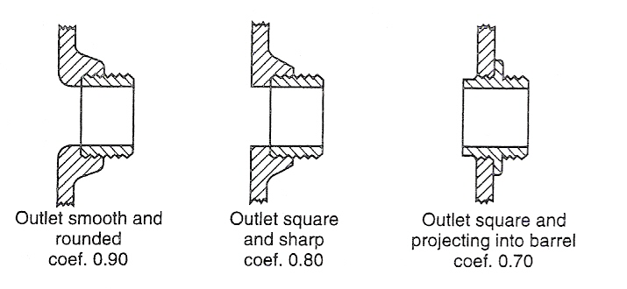
10. Put the cap having the gauge on this outlet, and turn hydrant on noting pressure. This shall be recorded as "Static Pressure" on the inspection form.
11. Turn off hydrant and remove the other cap (the one not having the gauge). Turn hydrant on as much as possible and note pressure on gauge. This shall be recorded as "Flowing Pressure" on the inspection form. These coefficients will be used later to determine water flow rate.
12. Turn off hydrant and check any other caps to ensure that they can be opened with minimum force. Put a light coating of graphite/oil mixture on the threads of the discharges.
13. Replace all caps and barely snug with hydrant wrench. Be careful not to over-tighten.
14. Record any problems with hydrant. Examples are: Shrubs too close, guards too close (interfering with turning hydrant on), leaks at ground level, caps on too tight (and cannot be removed), too low (wrench cannot make full circle when removing cap), does not drain, does not operate, low pressure (less than 20 psi flowing pressure), etc.
15. Often civilians will ask the firefighters for the reason they do this, as it gives their water a rusty appearance. These persons should be informed that the appearance is only temporary. The purpose of the hydrant testing is to ensure reliability in the event of a fire. Testing of hydrants also leads to their insurance rates being the lowest possible.
16. The hydrants will be numbered and a master map showing the hydrant and its number will be attached to the testing sheet; ensuring that the proper hydrant is tested.
17. The grease fitting on the operating nut shall be lubricated.
18. It should be noted that a high degree of accuracy is not required. The purpose of flow testing is to determine the possible number of fire streams that could be obtained from the system.

